HW5_1

 

Method 1

1. 先將Force除上面積A得到stress, deformation除上厚度t得到strain, 之後找出最大值將stress及strain正規化

2. 接著找出兩曲線峰值座標差Δt, 又ω = 2πf, 得到δ = ω Δt

3. , ,



Method 2

1. 將stress對strain作圖, 得到橢圓的圖形

2. 找出最大strain的位置, 與原點連線即G’

3. 與y軸交點為 $G^{''}γ_{0}$,所以除上最大strain $γ_{0}$, 即是G’’

4. $η=\frac{G^{''}}{G'}$



Discuss



1. 7.5mm G’ and G’’ smaller than 2.5mm.
2. 7.5mm stress-strain area is larger.
3. 7.5mm strain is larger, so stiffness is smaller.

HW5_2



K_total =

[[14400000.00412613 -7000000.00206306 0. ]

[-7000000.00206306 14400000.00412613 -7400000.00206306]

[ 0. -7400000.00206306 7400000.00206306]] $N/m^{2}$

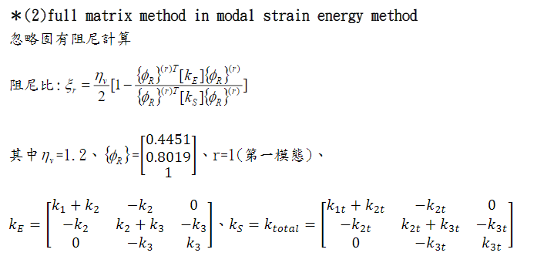

$$ξ_{r}=0.03305622$$

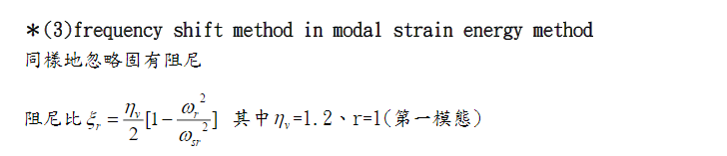

$$ω_{r}^{2} and ω_{sr}^{2} use eignvalue get (np.linalg.eig in python)$$

$$ξ_{r}=0.03339896823005983$$

HW5_3

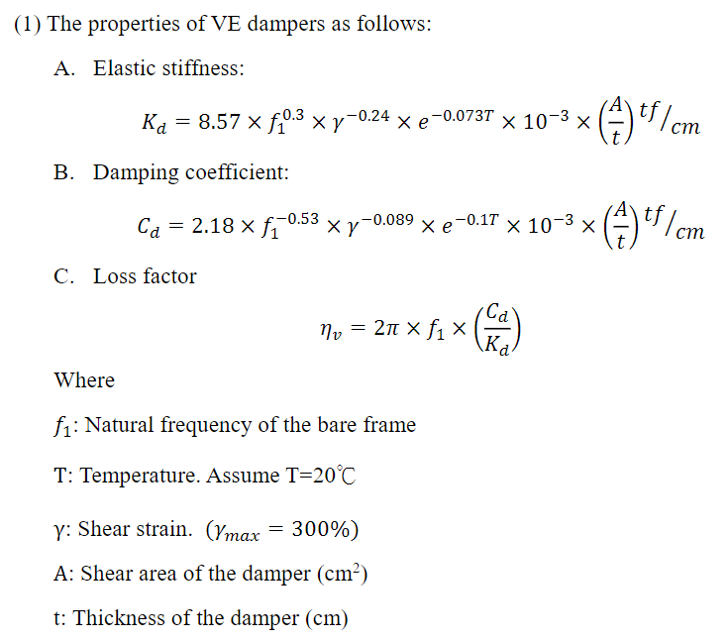

Try and error to get Kd Cd and $η_{v}$

Result:

Kd: 2958.8310418740784

Cd: 205.77600079596348

$η_{v}$: 1.3281848637356404

$ξ_{r}$: 0.20023210659258528 = 20.02%







